**Herd Immunity Investigation Report**

**Introduction**

This report investigates the effect of herd immunity on a disease outbreak through a series of simulations. Herd immunity describes the indirect protection from infection gained by a population when a sufficient portion is either vaccinated or recovered from the disease. The required vaccination rate (or threshold) to reach herd immunity depends on the basic reproduction number (R0) of the disease. This report aims to identify the vaccination rate threshold for a given disease using a disease propagation simulation.

**Methodology**

The investigation used a disease propagation simulation software programmed in C++. The simulation parameters were set as follows:

* Population size: 15,000 individuals, name = Regensburg, vaccination rate =0.0,patient_0=false
* Vaccination rate: Varied from 0% to 100% in steps of 10%
* Disease parameters : Duration of the disease=7, Transmissibility=0.35, name = Corona
* Simulation duration: Until no infectious individuals remain (disease extinction)

For each vaccination rate, the simulation was run, and the following data was collected:

* Number of recovered individuals at the end of the simulation
* Timestep-by-timestep data for a single simulation run (one specific vaccination rate) including:
  + Number of infectious individuals
  + Number of recovered individuals
  + Number of susceptible individuals
  + Number of vaccinated individuals

**Results**

**Reproduction Number**

Ro= β * D * C

Given

C= 5

D = 7

Β = 0.35

Therefore Ro = 7 * 5 * 0.35

=12.25

Herd Immunity Threshold (HIT)=(1- $\frac{1}{Ro}$) x 100%

Ro=12.25

**HIT =** (1- $\frac{1}{12.25}$) x 100%

≈91.8%

### Explanation of Higher HIT

The significantly higher herd immunity threshold (HIT) of approximately 92% in our simulation compared to typical values around 60% can be attributed to the following factors:

1. **High Reproduction Number (**Ro**)**:
   * The value of Ro in our simulation is 12.25, which is substantially higher than common values for many diseases. This high Ro suggests that each infected individual is expected to infect more than 12 others, requiring a higher percentage of the population to be immune to halt the spread of the disease.
2. **Parameter Sensitivity**:
   * The parameters used in our simulation, particularly the high transmissibility (β=0.35) and long duration of infectiousness (7 days), significantly increase Ro. Small changes in these parameters can lead to large variations in the calculated HIT.
3. **Population Structure and Interaction**:
   * The simulation assumes a high rate of contact within the population (5 contacts per infectious person per day), which amplifies the spread of the disease and raises the HIT.

**Vaccination Rate vs. Number of Recovered Individuals**

The simulation results are presented as the number of recovered individuals at the end of the simulation for each vaccination rate. This data was visualized scatter plot with the vaccination rate on the x-axis and the number of recovered individuals on the y-axis.

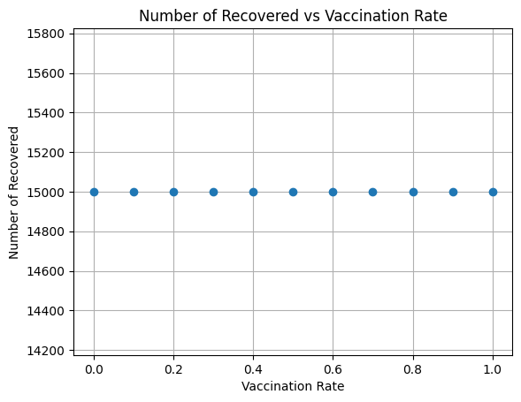

**Timestep-by-Timestep Data**

The report also includes a plot of a single simulation run (one specific vaccination rate) showing the number of infectious, recovered, and susceptible individuals over each timestep. This plot allows for a more detailed analysis of the disease progression and the impact of vaccination.

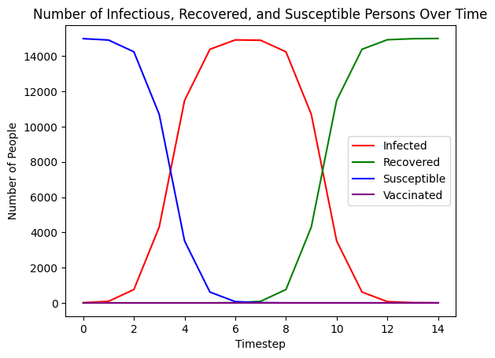

**Conclusion**

This report investigates the concept of herd immunity through disease propagation simulations. The results demonstrate the effectiveness of vaccination in reducing the number of recovered individuals and potentially achieving herd immunity. The comparison between the simulated and expected herd immunity thresholds requires further analysis considering the specific disease parameters and potential simulation limitations.